A Beauty Center Project

* **Introduction :**

This project was built with Python through Pycharm ,it is about a beauty center which provides several offers and services , each service and offer has it’s own price , The costumer will choose anything he wants then he will be able to know how much he has to pay due to services or offers he chose .

* **About The Program :**

It includes read and write from a file , multiple data structures such that loops , and the most

important thing the GUI interface .

1. 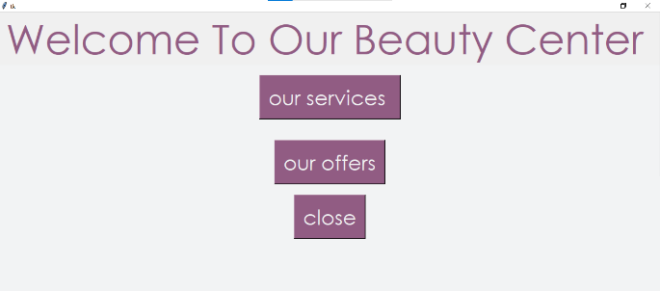Firstly the first screen will be shown to the user which include three main buttons (services , offers and close) .

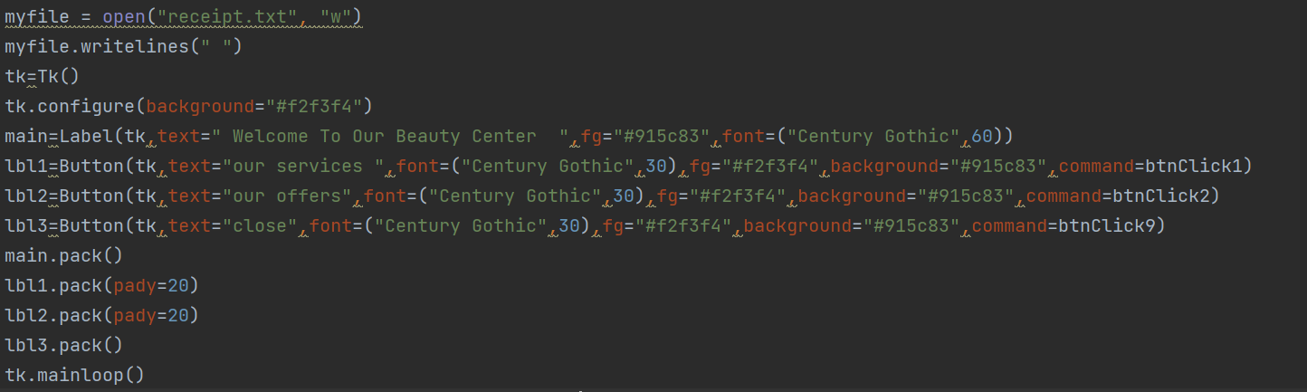

Each button is linked with a def using the attribute “command” , and each def contains a process that the program should do when the user click on it ,

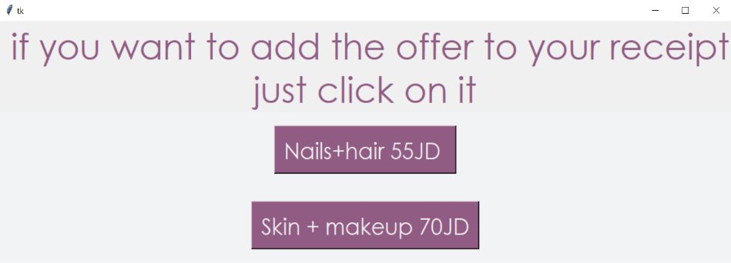If he/she click on the “services “ or “offers”  
 button ,the second page will be shown and presents the main services and offers with their prices .

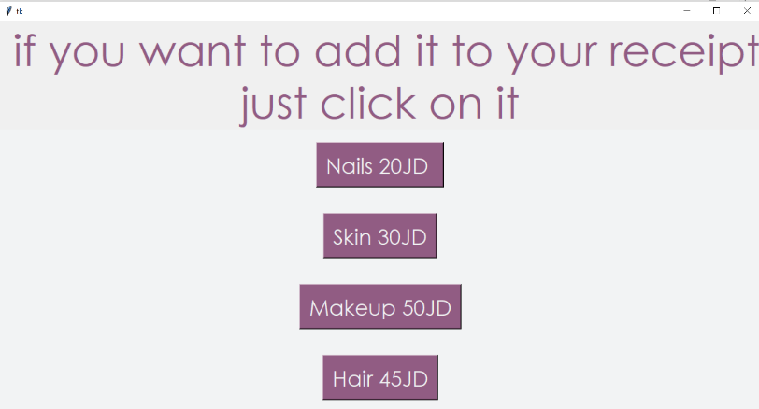

And here is the code :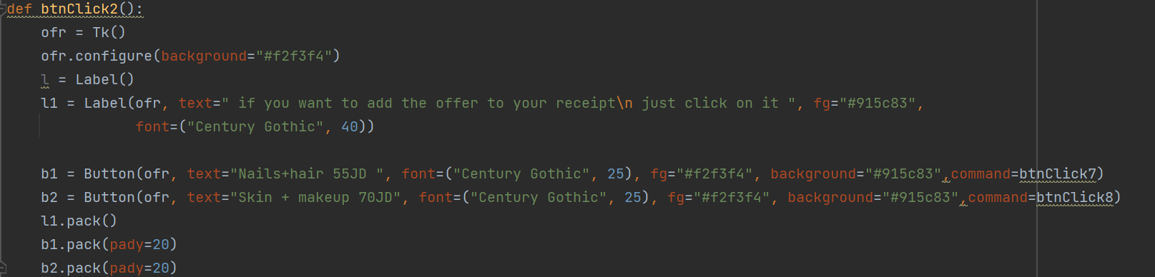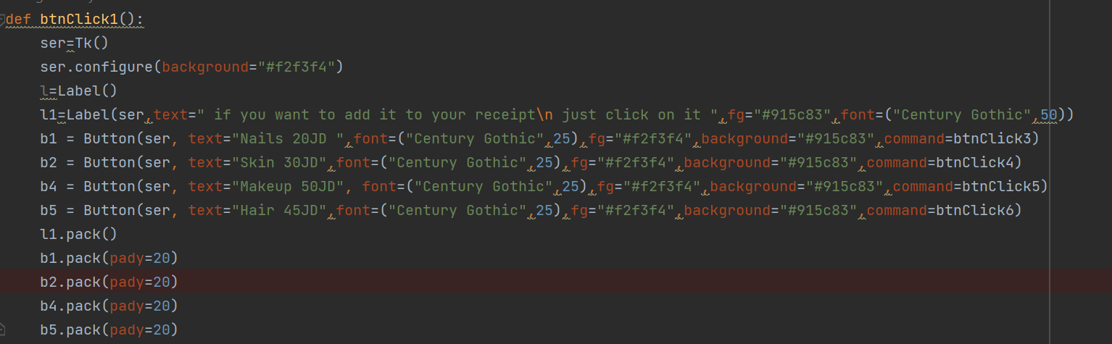

Each button here is also linked with a unique def that will append the service or offer and its price of it to a file named “receipt “ .

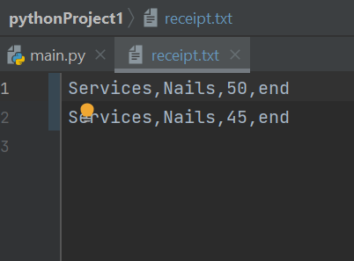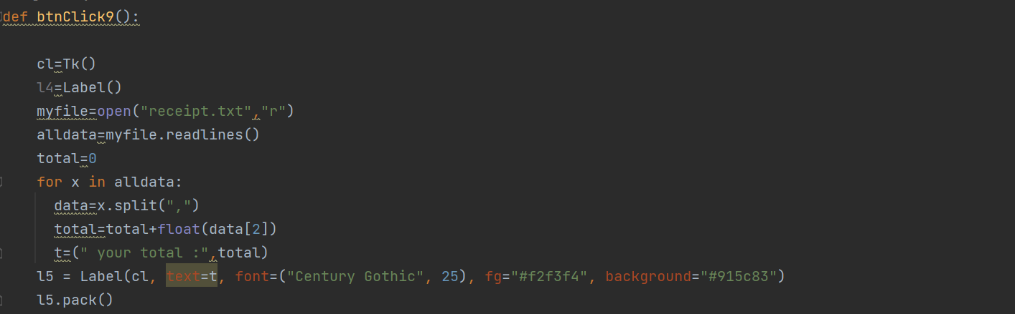The last screen will be shown when the user click on the close button in the first screen which linked with a def that will read the “receipt” file and calculate the total payment , the price will be in index (2) , the last screen will show the total payment to the user .

